|  |  |
| --- | --- |
| E-commerce and What are its Applications  customers insights  **Shopee, Brazil** | **Abstract**  **Using dashboard as a powerful analytical tool to consolidate crucial information from different aspects of an online business (Shopee, Brazil) into a central, visual interface. It allows the company to examine, monitor, and draw actionable conclusions from key performance indicators (KPIs) pertinent to online sales.**  **Ezeh C.L**  **Data Science** |

# **Introduction (Project Information)**

**Name of student:**

**Ezeh Chukwunonso Lawrence**

**Name of School:**

**Xaltiux Academy**

**Course:**

**Data Science**

**Project Company**

**Shopee, Brazil**

# **Title.**

**To create a customer base, enhancing the customer experience and recommend relevant products to the customers and increase revenue for shopee, brazil.**

**Prepared for Mrs. SHIVANGI, tutor,**

**xalxius academy.**

**by**

**ezeh chukwunonso lawrence**

**date**

**march 31st, 2025**

# **Table of Content**

**Introduction (Project Information)** i

**Title.** ii

**Table of Content** iii

**Figures** iv

**Chapter 1.** **Introduction** 1

**1.1. Problem Statement** 1

**1.2. Objective Research** 1

**1.3. Data Understanding and Preparation** 1

**Chapter 2. Key findings/Insights** 2

**2.1. Overall Findings** 2

**2.2. Customer Demographics Analysis** 2

**2.2.1. Gender Distribution** 2

**2.2.2. Country Distribution** 3

**2.2.3. Age Distribution** 3

**2.2.4. Income Distribution** 3

**2.3. Product Sales & Revenue Insights** 4

**2.3.1. Quantity Sold (by Country and gender)** 4

**2.3.2. Top-Selling Products (by Quantity Sold)** 4

**2.3.3. Top Revenue-Generating Products** 5

**Chapter 3. Recommendations and Conclusion** 6

3.1**. Customer Demographics Insights** 6

**3.1.1. Business Recommendations:** 6

**3.2. Product Sales & Revenue Performance** 6

**3.2.1. Business Recommendations:** 6

# **Figures**

**Figure 1: Total Products sold………………………………………………………………...………...……...2 Figure 2: Total Customers 2**

**Figure 3: Gross Profit………………………………………………………………………………………….2 Figure 4: Net Profit 2**

**Figure 5: Number of Customers by gender 2**

**Figure 6: Top Selling Customers by Country 3**

**Figure 7: Customers by age 3**

**Figure 8: Maximum income of Customers by Country 3**

**Figure 9: Minimum income of Customers by Country 4**

**Figure 10: Quantity of products sold by Country and gender 4**

**Figure 11: Top -Selling Products 4**

**Figure 12: Top -Revenue Generating Products (Net Profit Per Product) 5**

# **Chapter 1. Introduction**

This chapter defines the problem situation, and the research objective

# **1.1. Problem Statement**

Shopee, a Brazilian based company that is strongly into e-commerce is looking to create a customer base, enhancing the customer experience and recommend relevant products to the customers and increase revenue as per the information present

# **1.2. Objective Research**

The task is to generate a report with some important insights which can be helpful for the company to better understand their customers. by exploring the dataset of the company and come up with the solutions. The data provided contains all the required detail such as orders, customer demographics, products and the segment information, quantity, shipping cost etc.

# **1.3. Data Understanding and Preparation**

First step towards the analysis is to understand and prepare the data I have, once I get the idea about the features given in the dataset and the relationship among the variables then I can start preparing the dataset for the data analysis. • Data preparation is important because I need to transform the data as per the requirements like imputing missing values, changing the data type, deriving a custom column etc.

# **Chapter 2. Key findings/Insights**

This chapter highlights major findings during analyses and visualizations from the data provided by Shopee, Brazil. After visualizing and analysing the data provided by the company, major finding and insights were derived from the dataset. These findings/insights are divided into overall findings, customer demographic, and product sales and revenue insights.

# **2.1. Overall Findings**

## The overall findings/insights made during analysis and visualization are the total revenues with and without tax overall number of customers and the overall number of products sold in all four countries.

***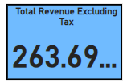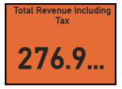******Figure 1: Total Products sold Figure 2: Total Customers***

# ***Figure 3: Gross Profit Figure 4: Net Profit***

# **2.2. Customer Demographics Analysis**

This involves studying and categorizing customer data (like age, gender, income, location) to understand your target audience and tailor marketing and product strategies effectively.

# **2.2.1. Gender Distribution**

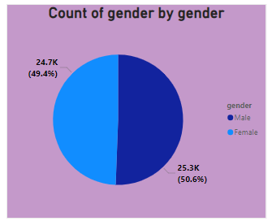There is a fairly balanced distribution of male and female customers.

# ***Figure 5: Number of Customers by gender***

# **2.2.2. Country Distribution**

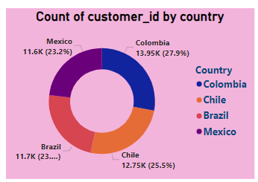The majority of customers are from Columbia, followed byChile, Brazil and Mexico

# ***Figure 6: Top Selling Customers by Country***

# **2.2.3. Age Distribution**

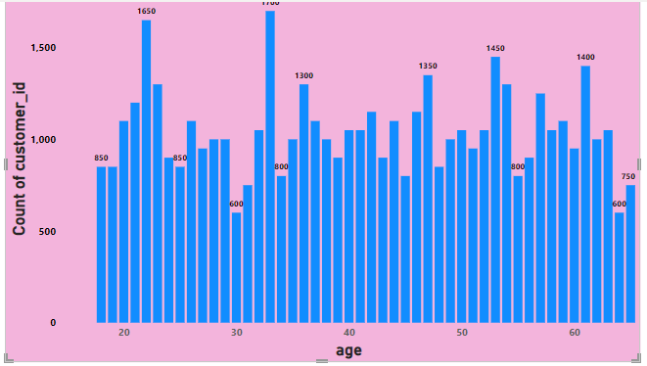Customers are primarily between 25-65 years old, with an average age of 41 years.

# ***Figure 7: Customers by age***

# **2.2.4. Income Distribution**

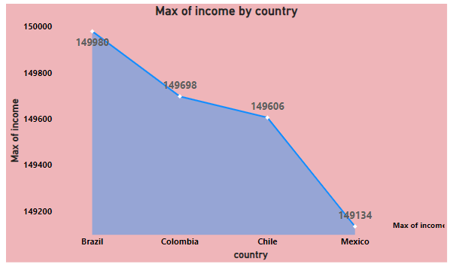The customers with high income are from Brazilfollowed byColombia, Chile and Mexico

# ***Figure 8: Maximum income of Customers by Country***

# ***Figure 9: Minimum income of Customers by Country***

# **2.3. Product Sales & Revenue Insights**

This is to gain a comprehensive understanding of product sales and revenue,

# **2.3.1. Quantity Sold (by Country and gender)**

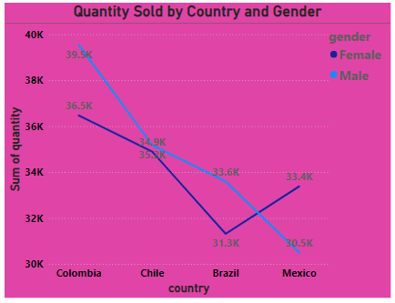High quantity of products bought by customers (both male and females) from Colombia, followed by Chile, Brazil, and Mexico.

# ***Figure 10: Quantity of products sold by Country and gender***

# **2.3.2. Top-Selling Products (by Quantity Sold)**

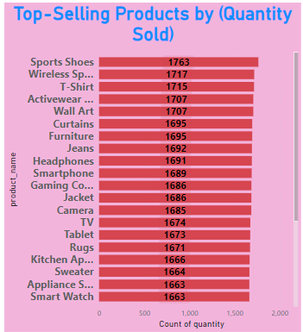Certain products have significantly higher demand, with sporty shoes and wireless speakersamong the most frequently purchased. These high-volume products likely drive customer engagement and retention.

# ***Figure 11: Top -Selling Products***

# **2.3.3. Top Revenue-Generating Products**

Some high-priced items generate more revenue despite not be among the top selling products.

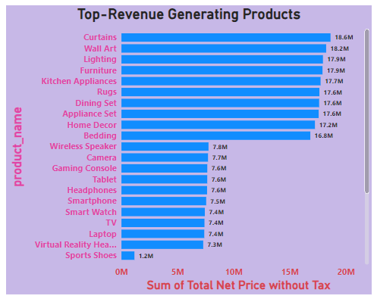Curtains**,** wall art**,** and lightings contributed the most to total revenue.

# ***Figure 12: Top -Revenue Generating Products (Net Profit Per Product)***

# **Chapter 3. Recommendations and Conclusion**

# **3.1. Customer Demographics Insights**

* + - * Customers are **evenly split between male and female buyers.**
      * The majority of customers are from **Colombia, followed by Brazil, Chile**, and Mexico
      * Age distribution shows **most customers are between 25-65 years old**, with an average age of **41 years**.
      * Income levels vary widely, ranging from **$20,205 to $149,980**, with an average of **$84,3400** for males and $85,050 for males.

# **3.1.1. Business Recommendations:**

* Target age groups 25-65 with marketing campaigns, as they form the core customer base.
* Colombia-focused promotions may yield higher sales due to a larger customer base.

# **3.2. Product Sales & Revenue Performance**

* Sporty shoes and wireless speakers are the most frequently purchased product categories.
* Discounting strategies impact sales: Higher discounts lead to more purchases, but need monitoring for profitability.

# **3.2.1. Business Recommendations:**

* Optimize discounts to maximize both sales volume and profit margins.